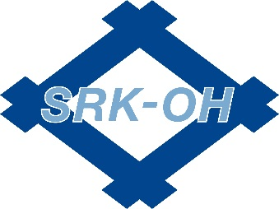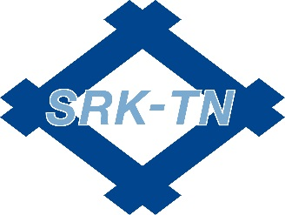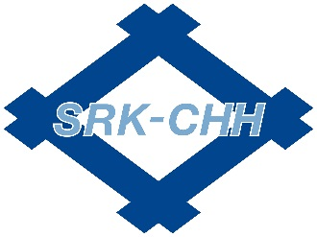

**TS- 16949 Quality System Registration Waiver**

Supplier Name: Date:

Supplier Location:

Type of Product(s) Supplied to SRK:

Current Quality System certifications: (*expiration date)* Are you pursuing TS 16949

Certification?

*circle one*

Yes No

Estimated date of certification:

Scope of certification:

Other automotive customers: *check the applicable box that describes your relationship*

|  |  |  |  |  |
| --- | --- | --- | --- | --- |
| Company | Tier 1 | Tier 2 | Tier 3 | Other |
|  |  |  |  |  |
|  |  |  |  |  |
|  |  |  |  |  |
|  |  |  |  |  |

*Attach additional pages if necessary*

As a supplier to SumiRiko, you are held to the expectations and requirements of the most recent SumiRiko Supplier Policy Manual. Although your Quality System has not been certified to the TS-16949 Quality Management Systems standard, you are responsible to meet SumiRiko’s requirements as defined in the Supplier Policy Manual and all SRK drawings and specifications.

SumiRiko places great value on the effort for continuous improvement that is the foundation of the TS-16949 standard. The expectations defined within the SumiRiko Supplier Policy Manual are a minimum requirement and SumiRiko fully expects its suppliers to continually work towards the improvement of their processes and products.

|  |  |  |  |  |  |  |  |  |
| --- | --- | --- | --- | --- | --- | --- | --- | --- |
| Supplier Signature | | | |  | SumiRiko Approval | | | |
| Submitted by: | | |  |  | Approved by: | |  | |
| Title: |  | | |  | Date: |  | | |
| Date: | |  | |  |  | | |  |